Objective
After completing this assignment, the student will be able to:

a) Define the functions XIC (Examine If Closed), XIO (Examine If Open), and OTE (Output Energize).
b) Edit and Monitor the program using RSLogix 500 Software

References
Cox, Technician's Guide to Programmable Controllers, Ch 7
Allen-Bradley, RSLogix 500 Software Instruction Help Screen

Materials Needed
Allen-Bradley MicroLogix 1400 programmable controller with simulator
RSLogix 500 and RSLinx Software

Discussion
The three most basic instructions in any A-B controller are the XIC, XIO and OTE. In this lab the RSLinx software will be used to establish communication with the MicroLogix 1400 and the RSLogix 500 software will be used to do the programming. The instructions in the controller fall into two categories called “read” and “write”. Read type instructions don’t turn anything on or off, they simply read information from a particular “address” or location in the controller. Read type instructions are placed on the left side of the ladder logic in the program. A write type instruction turns things on and off or changes the data in some fashion. Write type instructions are placed on the right side of the ladder logic in the program.

The XIC is the Examine If Closed or also known as the Examine On instruction and it is a read instruction. This instruction is similar to a normally open contact in relay logic. The symbol for XIC looks like this: -] [-. In relay logic, a normally open contact is used so that when a relay is energized there is electrical continuity across the contact. In PLC logic, also known as “scanned logic”, the XIC examines the address to see if it is “closed” or “on” and if it is we have “true” logic. In relay logic the “logic” is done with the wiring, where as in PLC the logic is done in software. An “on” or “closed” condition in the PLC will have a “1” in the data table. This instruction doesn’t turn anything on or off, it just reads the condition of the address. Think of it as a logical question. The programmer uses the XIC to “ask” the PLC if the address is “on” or “closed”. If there is a “1” in the data table at the address, then the answer is “true” and if there is a “0” in the data table, then the answer is “false”. There are only two possible conditions that a single bit in the PLC can be, either “on” or “off”.

The XIO is the Examine If Open or also known as the Examine Off instruction and it is also a read instruction. This instruction is similar to a normally closed contact in relay logic. The symbol for XIO looks like this: -] / [-. In relay logic, a normally closed contact is used so that when a relay is de-energized there is electrical continuity across the contact. In scanned logic, the XIO examines the address to see if it is “open” or “off” and if it is then it has “true” logic.

An “off” or “open” condition in the PLC will have a “0” in the data table. It is also a logical question. The programmer uses the XIO to “ask” the PLC if the address is “off” or “open”. If there is a “0” in the data table at the address, then the answer is “true” and if there is a “1” in the data table, then the answer is “false”.

With these two instructions, XIC and XIO, a programmer is able to ask the PLC if something is “on” and get a true answer and ask if something is “off” and get a true answer. By arranging these “questions” in series and or parallel, the programmer can create logical sequences using software, rather than wiring the logic through mechanical contacts.

The OTE is the Output Energize instruction and it is a write instruction. This instruction is similar to a coil on a relay in relay logic. The symbol for OTE looks like this: -( )-. When the rung conditions the OTE is on are true, it writes a “1” in the data table address that is on the OTE instruction. When the rung conditions the OTE is on are false, it writes a “0” in the data table address that is on the OTE instruction. This instruction turns things on and off in the data table or if it is addressed to a physical output address, things get turned on and off outside the PLC. This instruction allows the programmer to make logical decisions in the internal logic as well as start and stop equipment outside the PLC. If there is a “1” in the data table at the address, then the OTE instruction is “true” and if there is a “0” in the data table, then the OTE instruction is “false”.

The input terminals of the programmable controller are all numbered. These numbers are called "addresses". XIC instructions in a program are able to use these addresses to determine if the input device is “on” or if the device is “closed”. If power is supplied to the input terminal address, then a “1” is in the data table at that address and the instruction is “true". If no power is supplied to the input terminal, then a “0” is in the data table at that address and the instruction is "false". XIO instructions in a program are able to use these addresses to determine if the input device is “off” or if the device is “open”. If power is supplied to the input terminal address, then a “1” is in the data table at that address and the instruction is “false". If no power is supplied to the input terminal, then a “0” is in the data table at that address and the instruction is "true".

MicroLogix 1400 Input addresses are:
I/0 - I/19 for a total of 32.

MicroLogix 1400 Output addresses are:
O/0 - O/11 for a total of 32.

The RSLogix 500 software on the computer will be used to write the program and monitor the operation. The RSLogix 500 software can be used to program and monitor anything in the SLC 500 or MicroLogix family. With the software you can document and save all of your programs, print them out, perform on and offline cross referencing and even get help with all of the instructions. When this Lab indicates to “click” that refers to one click of the left mouse button. A “right click” refers to one click of the right mouse button. “Dragging” means to click the left mouse button on something and hold down as you move the cursor of the mouse.

Lab Procedures

1. Place all of the input toggle switches down and energize the programmable controller. Connect the serial cable from the computer to the controller.

2. Open RSLinx by clicking on the “start” button, then All programs, Rockwell Software, RSLinx and finally RSLinx Classic. RSLinx is an OPC (OLE for Process Control) server and is the communications server for the Rockwell Automation products. To use the serial cable a DF1 driver needs to be configured. DF1 is a peer-to-peer link-layer protocol that combines features of ANSI X3.28-1976 specification subcategories D1 (data transparency) and F1 (two-way simultaneous transmission with embedded responses). On the RSLinx menu bar click on Communications then select Configure Drivers. From the drop down in the Available Driver Types frame, click on RS-232 DF1 devices, as shown below, and then click on the Add New button.
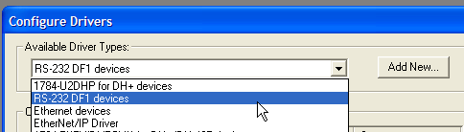

When the window opens, prompting you for a name, accept the default name by clicking on the OK button. This takes you to the configuration window. Make a note of all of the settings in the default in the spaces below:

Comm Port ________________ Device ______________________

Baud Rate ________________ Station Number _______________

Parity ____________________ Error Checking ________________

Stop Bits _________________ Protocol ______________________

Make sure the Comm Port is set to COM1 and click on the Auto-Configure button. After getting the message “auto configuration successful”, record the settings:

Comm Port ________________ Device ______________________

Baud Rate ________________ Station Number _______________

Parity ____________________ Error Checking ________________

Stop Bits _________________ Protocol ______________________

The RS-232 DF1 driver would be a very difficult driver to configure if you had to try all of the different possible combinations of Baud Rates, Devices, Parity, etc., but the Auto-Configure button makes short work of it. Click the OK button on the configuration window and then click the close button on the configure drivers window. On the RSLinx toolbar, click on the RSWho icon, as shown to the right:
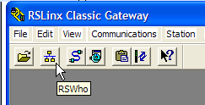
The AB_DF1-1 driver now shows up with a plus sign next to it. Click on the plus sign and the window expands to show all of the nodes on the network, which should show your computer as node 0 and the MicroLogix 1400 as node 1. If your screen is showing this then the driver is ready to go. If you are not getting the MicroLogix to show, notify your instructor to help resolve the issue. This may seem like several steps to go through, but after doing it a couple of times you’ll find that it goes very fast.

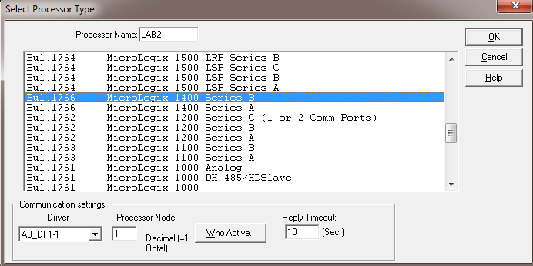
3. It is now time to open the programming software, RSLogix 500. Open RSLogix 500 by clicking on the “start” button, then All programs, Rockwell Software, RSLogix 500 English and finally RSLogix 500 English. This places you at the opening screen of the RSLogix 500 program. Click on “File” on the menu then click on “New” to start a new program. The Select Processor Type window is now open and we have to make some selections. In the processor name box type Lab2. Slide the bar down until you see a selection titled MicroLogix 1400 Series B and click on it so it is highlighted. Verify the AB_DF1 is selected in the Driver box and if not, select it as the driver. Your window should look similar to the one below:

If your window looks like the one above, click the OK button. If your window looks different, try the procedure again and if it still doesn’t match, have the instructor walk through it with you.

4. The programming environment for the MicroLogix 1400 has now been created and you’re ready to start writing the program.

5. Add a rung:
a) In the Lad 2 side of the window, right click on rung 000 and select “Append Rung”. Notice that a new rung has been placed above the End rung and the End rung has now been assigned as rung 001. Append Rung would normally put a rung below where your cursor was sitting and Insert Rung would put a rung above where your cursor was sitting, but since you were on the End rung the software knew that a rung can’t go below the end.
b) Right click on the new rung zero and select Append Instruction. In the search window type XIC and then click OK. Notice that a XIC instruction was added and has a black box around it. The black box is indicating where your cursor is sitting.
c) Right click on the XIC with the box around it and select Append. In the search window type OTE and click OK.
d) Right click on rung 000 and click on Append Rung.
e) Right click on the newly created rung 001 and click Append Instruction. In the search window type XIO and click OK.
f) Right click on the XIO instruction with the black box around it and select Append. In the search window type OTE and click OK.
You should have something similar to the picture below:

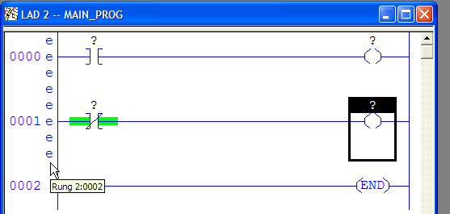

The question marks indicate that an address is needed. The “e” on the left side means that these rungs are in the process of being edited. The software will not allow this to be downloaded at the moment because there is information missing. You could, however, save this program as is to your computer and come back and work on it later. The software is designed to be a “free form editor” meaning you can concentrate on the structure of the rungs and add the details later.

6. Add the addresses:
a) In the project tree on the left, under Data Files, right click on I1-Inputs and select Open.
b) In the top row of zeros drag the right most one to the XIC instruction on rung 000 and when the red square there turns green, release the left mouse button. The address I:0.0/0 should now be on that instruction.
c) In the top row of zeros drag the one under the number 4 to the XIO instruction on rung 001 and when the red square there turns green, release the left mouse button. The address I:0.0/4 should now be on that instruction. Click the red X in the upper right corner of the Data File to close it.
d) Referring to step 6a above, open the O0-Outputs file.
e) In the top row drag O:0.0/5 to the OTE on rung zero then drag O:0.0/0 to the OTE on rung 001 and close the Data File.

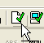
All of the instructions should now have addresses on them, but the “e” is still showing on the left. On the tool bar, locate the Verify File icon (shown on the right) and click on it. If all goes well the “e” will be gone and the program is ready to be downloaded to the processor. If there is a problem the software will indicate errors in a window at the bottom of the screen and they will need to be corrected and verified before the program can be downloaded.

7. Download the program:
a) In the upper left corner of the screen, click on the drop down arrow and click on Download. If the Revision Note window opens up, click the OK button.
b) Click on the Yes button when the dialog box asks if you want to proceed with the download.
c) Click on the Yes button if a message says the processor must be switched to PROG mode.
d) Click on the Yes button if you want to change back to the run mode.
e) Click on the Yes button when asked if you want to go online.

You should now have a window that looks like this:
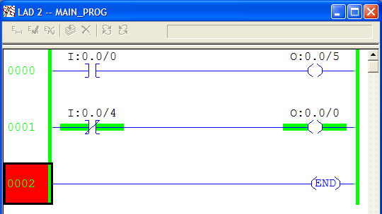

Notice the ladder spinning in the upper left hand corner. This indicates you are online with the processor monitoring the program.

8. Look at the XIC instruction on rung 0. It doesn’t have the green handles beside it, signifying that the instruction displayed is presently false. Turn on toggle switch 0.
Q1. What happens to the XIC when the switch is on?

____________________________________________________________________

Q2. What do the green handles mean?

____________________________________________________________________

Q3. Right click on the XIC and select Goto Data Table. What value is at the address?

_____________________________________________________________________

Q4. Look at address I:0.0/4 in the Data File and record the value here. ____________

Why does the XIO instruction have green handles when the switch is off?

_____________________________________________________________________

Q5. Turn switch 4 on and record the value shown in the Data File here. ____________

What happened to the green handles? Why is this?

_____________________________________________________________________

Q6. Turn switches 0 and 4 on and off, observing the OTE instructions on rung 000 and 001.
What do the OTE instructions do when the rung conditions are true?

_____________________________________________________________________

Q7. What do the OTE instructions do when the rung conditions are false?

_____________________________________________________________________

